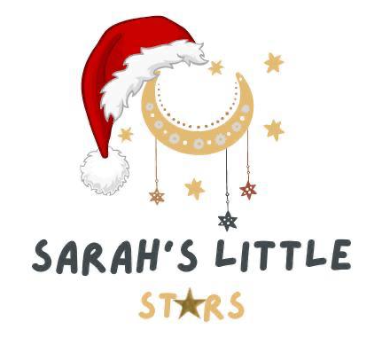

20/11/22

Hello everyone

Can you believe its 35 sleeps till CHRISTMAS? I won’t lie this makes me very happy!!
In light of this amazing news, I would like to tell you about our amazing Christmas raffle that we are holding.

The money raised will go towards staff training.
For those who remember, myself, Claire and Hollie attended a course in the summer on supporting children’s behaviour with a man called Ben Kingston, he is the most amazing trainer and I’ve had the privilege of attending his training twice now.

This training will be for staff and parents to attend and will take place on a weekend- Saturday 11th March’23, this is a fantastic opportunity and I know you’re going to love it.
Depending on numbers, maybe only 1 parent can attend but I will try and work it out with Ben.

Now, this raffle isn’t any old raffle! None of your boring old box of chocolates and a cheap bottle of wine from the back of the cupboard. Ha-ha

Everything has been brought either from me, the team or generously donated by local companies. We got so much stuff we decided to do not 1 but 3 hampers!!!!!!

1st prize Hamper
- Tonies box with 3 Tonies & 1 creative Tonie, brought by the staff!
- £150 gift voucher from myself which will be taken off January 2023 fees
- £200 voucher for a cut and colour at my favourite hair salon 31B down in the pantiles
- 4-hour Baby-sitting voucher with our lovely Becky
- A gorgeous bottle of wine from the secret cellar company in town
- The new Julia Donaldson book “The Baddies”
- Some delicious savoury snacks from the farm shop, that we attended for pumpkin picking
- A lovely selection of sweets from M&S
- Some very yummy chocolate from Hotel Chocolate
- A stunning wooden animal set from one of our favourite childcare company
“yellow door”
- A set of our favourite bubble mixture and wand from Dr Zigs
- And last by not least a discounted hotel stay code for Marriott hotels globally (if you take your time looking and playing around, you can actually get some fantastic discounted hotels!)

2nd prize Hamper
- £75 gift voucher from myself which will be taken off January 2023 fees
- 4-hour baby sitting voucher with the one and only me!
- A voucher worth £50 from Michelle (Thea mummy) for manic ceramix pottery cafe
- A meal for 1 from my favourite curry house in Langton green (Blue india)
- A bottle of wine from the farm shop, that we attended for pumpkin picking
- Some delicious savoury snacks from the farm shop, that we attended for pumpkin picking
- Touch and feel Zog book
- A wooden space star sensory toy from Petit Boum
- A lovely selection of sweets from M&S
- Some very yummy chocolate from Hotel Chocolate
- A stunning wooden animal set from one of our favourite childcare company
“yellow door”
- A set of our favourite bubble mixture and wand from Dr Zigs
- And last by not least a discounted hotel stay code for Marriott hotels globally (if you take your time looking and playing around, you can actually get some fantastic discounted hotels!)

3rd prize Hamper
- £50 gift voucher from myself which will be taken off January 2023 fees
- 4-hour baby sitting voucher with our lovely Sadie
- A voucher for 75% off a child or adult dance course/ 1 term from Sam (Elliott and big sienna mummy) for cascade dance
- 2 little bottle of flavoured gin from the farm shop, that we attended for pumpkin picking
- Some delicious savoury snacks from the farm shop, that we attended for pumpkin picking
- Touch and feel super worm book
- A pack of learning alphabet phonic cards from our favourite phonics teacher from Teacher-play.co.uk
- A lovely selection of sweets from M&S
- Some very yummy chocolate from Hotel Chocolate
- A stunning wooden animal set from one of our favourite childcare company
“yellow door”
- And last by not least a discounted hotel stay code for Marriott hotels globally (if you take your time looking and playing around, you can actually get some fantastic discounted hotels!)

I’m sure you can all agree these are some fantastic prizes.

If you would like to take part, simply all you need to do is pick a number from 1-100 on our Christmas board and write your name on the corresponding number list. Each number you pick is £5.
Tickets will be on sale from 24/11/22
I’m the only one who knows the 3 lucky numbers and the winners will be announced at our Christmas party on Friday 9th December at 8.30pm (before we are all too drunk ha-ha)

Reminders-

-The setting is closing early on Friday 9th Dec’22 at 5pm so staff can get ready for the xmas party
-Christmas jumper Day/Week is W/C 19th Dec’22
-Christmas dinner is on our last day Wednesday 21st Dec’22
-We are closed for our Christmas break from Thursday 22nd Dec’22 and we don’t reopen on Tuesday 3rd Jan’23 after the bank holiday.
- Thursday 12th Jan’23 the animal man is coming in at 1.30pm for 2h- A letter will come out about this in Dec’22- the children love animal man day. We will do 2 small groups so the children can take their time.
- we will be continuing our dance club next year with Sam from Cascade Dance- we will be moving the day, so I will keep you posted on that. I have decided to cover the cost again as the children really do love their dance club morning.
- In January we will be looking at space/ stars/ the sky and Lots of Light play!

That’s it for now!

Many thanks
Sarah & Team x

