
Dear parents

I can’t believe I’m saying this, but we are nearly in March! Where has January and February gone.

Anyway, lots of exciting news to tell you.
Ruth our new early years practitioner started on 1st of February and has settled in very well and the children love her. So, you will be meeting Ruth very soon.

Ali, our new assistant manager, has also started this week and a few of you have had the chance to say hi already. - me and Ali will be working very closely together to make some very exciting improvements plans.

Talking of improvements plans, when I started this little dream of mine last February’22 I didn’t think in my wildest dreams we would be full in just 3weeks of opening and in under 6 months of open that we would be expanding and designing our new garden!
We are so grateful to have this massive space and for TGS for giving me this opportunity.

So, by July we will gain the two extra rooms. This will need painting and turning around etc so anyone who’s good with a paint brush it’s your time to shine. Hehe
My idea is.
– room 3 will be a purpose-built baby room – and I’ll be working closely with a local company called Babba and me which some of you might know, as they are based down on the hill towards TW rail station, and one of my long-standing companies TTS on designing my dream baby room.
The 4th room will be our toddler room and our current room 1 and room 2 will turn into our preschool rooms.
Room 3 our baby room will also have its own free flow garden just like the first two rooms so everything will be purpose built for them.

So, it will be a big shuffle round but 100% worth it in the end. As much as I’m sad we won’t be together 100% of the day we will come together at the end of each day and when we hold special events.
This will also help with sickness – where we are all together at the minute it just spreads so much faster and wipes out all the staff at the same time. This way if there is a bug it can be contained to one room and less disruption will happen.

In our main garden the school kindly cleared away all the blackberries and thorn bushes for us and we have now started building our own forest school – the fencing started going in on 17th Feb which the children loved watching and I can’t wait for it to be finished.
I have loads of footage to sort through so that I can put together a REEL for you all to watch. The process so far has been amazing.

But for now, I’ll leave you with this sneak peek from Simon’s lockup. He is working very hard for me and the little stars…… I mean it doesn’t help that I keep thinking of new ideas and sending them over to add in haha

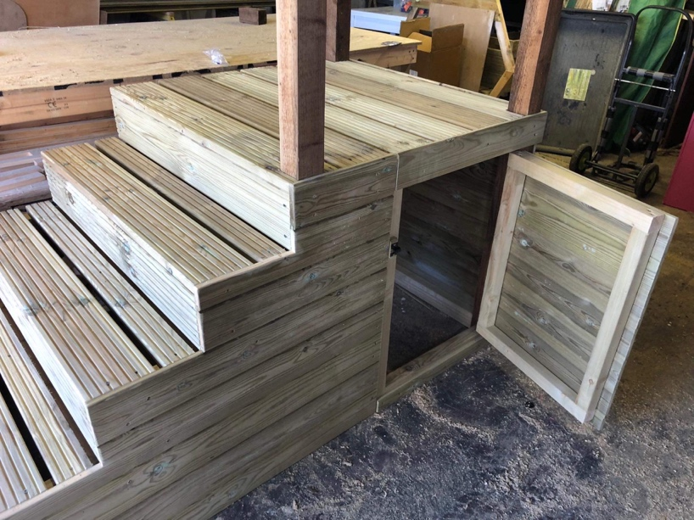

So, the Christmas seems like ages ago now and I was thinking about some drinks for those who can make it.
Barn pub Friday 31st March’23 say 7.30PM, nothing special just be nice for a quick catch up/chilled child free evening.

I am in the middle of planning a family day out at the farm for easter, so I’ll get back to you on this.

A reminder that we have our behaviour training for the staff and parents Sat 11th march’23 – 9AM, Ben is a fantastic trainer, and everyone is welcome. It will be great to see so many of you there.

Letters will be coming out very soon as we have booked to go to the theatre in march for ‘Room on the Broom” (x2 groups, 1 AM and 1 PM) and ‘Smeds and the Smoos’ in May (x1 Group in the AM)

And the last reminder is Monday 5th and Tuesday 6th June the setting is closed for staff training days and a setting deep clean. These days are chargeable and cannot be swopped around.

If you have any question please do not hesitate to contact me.
Sarah & Team x

